

**Ministry of Agriculture**

**Agricultural Marketing Section**

# MONTHLY MARKET BULLETIN

**September, 2024**

**Executive Summary**

Prices for major staple food crops increased and decreased at different rates in September than a month prior and also increased and decreased at different rates comparison to the previous year and to the five-year average. In September, increase in price was observed in maize (3.2%) wheat (2.4%) and round potatoes (0.7%), while price of sorghum and rice decreased by 3.1%, and 1.7% respectively, prices of beans remain constant international commodity prices in September, 2024 (except wheat and tea) owing to improved trade flows. Tanzania has an advantage in increasing commodity exports and reducing imports by improving production of edible oil, wheat, and fertilizer.

1



**1. Domestic Market Prices:**

## Staple foods Table 1: Changes in market price of major staple foods (%)

|  |  |  |  |  |  |  |
| --- | --- | --- | --- | --- | --- | --- |
|  | **Maize** | **Rice** | **Beans** | **Potato** | **Sorghum** | **Wheat** |
| Annual change (Sep 2023/24) | **▼33.2%** | **▼21.2%** | **▼1.3%** | **▲22.1%** | **▲13.8%** | **▲16.0%** |
| 5 Year average (Sep 2020-Sep  2024) | **▼8.0%** | **▲4.6%** | **▲18.6%** | **▲28.6%** | **▲20.5%** | **▲20.5%** |
| Monthly change (Aug-Sep 2024) | **▲3.2%** | **▼1.7%** | **►0.0%** | **▲0.7%** | **▼3.1%** | **▲2.4%** |

Prices for major staple food crops increased and decreased at different rates in September than a month prior and also increased and decreased at different rates comparison to the

previous year and to the five-year average (Table

1). In September, increase in price was observed in maize (3.2%) wheat (2.4%) and round potatoes (0.7%), while price of sorghum and rice decreased by (3.1%,) and (1.7%) respectively, prices of beans remain constant.

## Maize



In September, the average wholesale price increased by 3.2 percent,



from TZS 62,900/100kg bag in August to TZS 64,900 in September (Table 1). Despite the September price increase, maize prices remained 33.2% and 8.0% lower than the previous year’s comparable month and the five-year September averages, respectively (Figure 1).

-

20,000

40,000

60,000

80,000

100,000

120,000

Sep-20

Sep-21

Sep-22

Sep-23

Sep-24

TZS/100kg bag

Figure 1: Average market price of maize during month of

Sep 2020

-

2024

Market price

5

year average

3

## Rice

Rice prices decreased by 1.7 percent in September, declining from TZS

200,100/100kg bag in August to TZS 196,700/100kg bag in September (Table 1). Similarly, prices decreased by 21.2% in September compared to the previous year's same month, and increased by 4.6% compared to the five-year May averages (Figure 2).

-

50,000

100,000

150,000

200,000

250,000

300,000

Sep-20

Sep-21

Sep-22

Sep-23

Sep-24

TZS/100kg bag

Figure 2: Average market price of rice during month

of Sep 2020

-

2024

Market price

5

year average

**Dry beans**

Beans prices remain

constant in September. Price trend shows a decline in prices

over the past three months. However, prices in September remained significantly

lower by about 1.3% and 18.6% higher than similar month previous year and the five

-

year September average, respect

ively (Figure 3).

**Sorghum**

The monthly average wholesale price of sorghum fell by 3.1 percent in

September, declining from TZS 149,000/100kg bag in August to TZS

144,400/100

kg bag in September. However, prices remained higher at

% in May compared to the same month the previous yea

23

r, and were

% higher than the five

32

-

year May average. (Figure 4).

-

50,000

100,000

150,000

200,000

250,000

300,000

Sep-20

Sep-21

Sep-22

Sep-23

Sep-24

TZS/100kg bag

Figure 3: Average market price of dry beans during

month of Sep 2020

-

2024

Market price

year average

5

-

20,000

40,000

60,000

80,000

100,000

120,000

140,000

160,000

Sep-20

Sep-21

Sep-22

Sep-23

Sep-24

TZS/100kg bag

Figure 4: Average market price of sorghum during

month of Sep 2020

-

2024

Market price

5

year average

|  |  |  |
| --- | --- | --- |
| **Round potatoes**  In September, round potato wholesale prices increased by 22.1 percent, from TZS 105,500kg per bag in August to TZS 106,100/100kg bag in September. Similarly, prices remained 22.1% higher in the reporting period compared to the same period the previous year, and 28.6 % higher than the five-year September average (Figure 5).      -  20,000  40,000  60,000  80,000  100,000  120,000  Sep-20  Sep-21  Sep-22  Sep-23  Sep-24  TZS/100kg bag  Figure 5: Average market price of round potatoes  during month of Sep 2020  -  2024  Market price  5  year average | **Wheat**  Wheat grain wholesale prices increased by 2.4 percent in September, from TZS 185,700/100kg bag in August to TZS 190,200/100kg bag in September. Prices, on the other hand, were 16% higher in the reporting period compared to the same period the previous year, and 20.5% higher than the five-year September average (Figure 6). | |
|  | Figure 6: Average market price of wheat during month of Sep 2020-2024  200,000  -  50,000  100,000  150,000  Sep-20  Sep-21  Sep-22  Sep-23  Sep-24  TZS/100kg bag  Market price  5  year average |
|  |

## 2. Global Prices: Traditional Export commodities (Source: World Bank, 2024)

## Coffee

In September 2024, coffee prices have changed at different rates compared to August. Arabica prices increased by 6.4 percent but remained higher than they were a year ago. After a drop in Nov, Robusta prices have been increasing and increased by 12 percent in September (Figure 7). Weather conditions in East Asia have improved. Easing pressures on Robusta prices, recent concerns over Brazil’s Arabica production, arising from adverse weather in August, have reduced expectations of a bumper crop this year [(World Bank, 2024](https://openknowledge.worldbank.org/server/api/core/bitstreams/6864d537-d407-4cab-8ef1-868dbf7e07e2/content))

## Tea

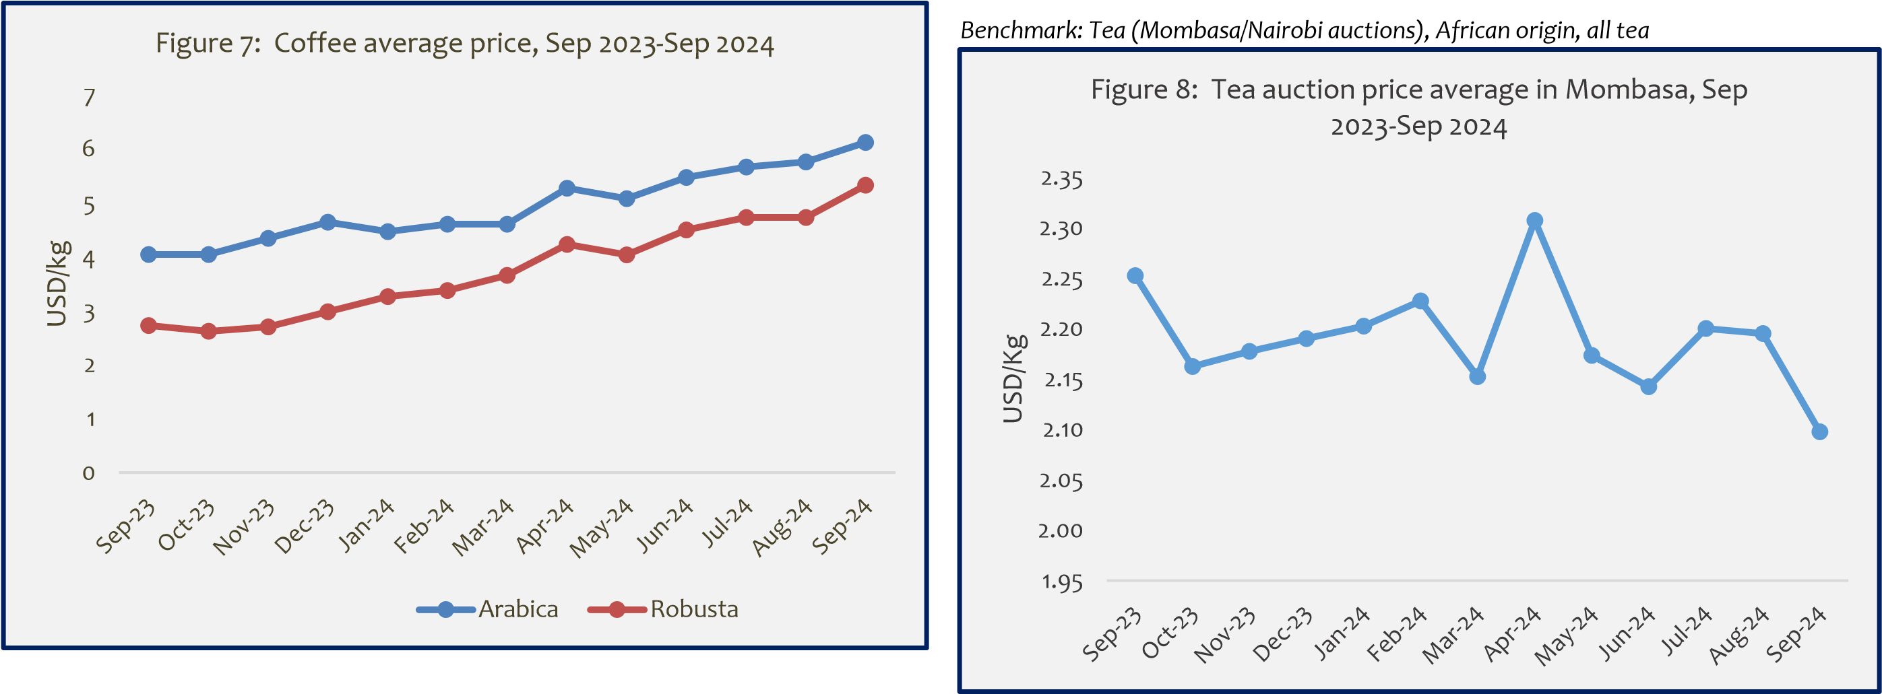International tea prices have been increasing and decreasing at different rate for the last year. Prices at the Mombasa auction market have decreased by 4.76 percent in September, compared to their prices in August, from USD 2.20/kg in August 2024 to USD 2.10/kg in September 2024 (Figure 8). Following an estimate 13 percent increase in 2024, tea prices are set to remain fairly flat in 2025, as a limited recovery in supplies in South Asia (especially India) and East Africa (notably Kenya) is balanced by subdued demand growth, particularly in the Middle East [(World Bank, 2024](https://openknowledge.worldbank.org/server/api/core/bitstreams/6864d537-d407-4cab-8ef1-868dbf7e07e2/content)).

|  |
| --- |
| **Tobacco**    Since January 2024, global tobacco prices have been increasing and decreasing at different rates (Figure 10). Prices picked up in July 2024 to 6013.53USD/ton and declined in August to    4889.62USD/ton but in September 2024 the prices slightly increased by 0.2% to 4899.14 USD/ton. |

## Cotton

Cotton prices peaked in March 2024, and then dropped significantly in the months that followed. Prices in September, 2024 slightly increased from 1.76 USD/kg of August t0 1.82 USD/Kg. Global consumption of cotton has weakened recently causing a decline in prices. After a decline of nearly 10 percent in 2024, cotton prices are projected to rebound in 2025 and 2026 as supply growth moderate.

## 3. Import Substitution Commodities (Source: World Bank, 2024)

### Wheat

Ukraine and Russia accounted for nearly 30% of global wheat exports. Following several months of Russia’s invasion of Ukraine, priceof wheat have soared. However, wheat observed a decline in prices from September 2023 reflecting improved supply prices (Figure 11). Wheat price, which are set to drop by 21 percent in in 2024, are forecast to edge lower by further 2 percent in 2025. Tanzania imports about 90% of domestic wheat requirement.

*\*Wheat (US), Hard Red Winter (HRW) and Soft Red Winter*

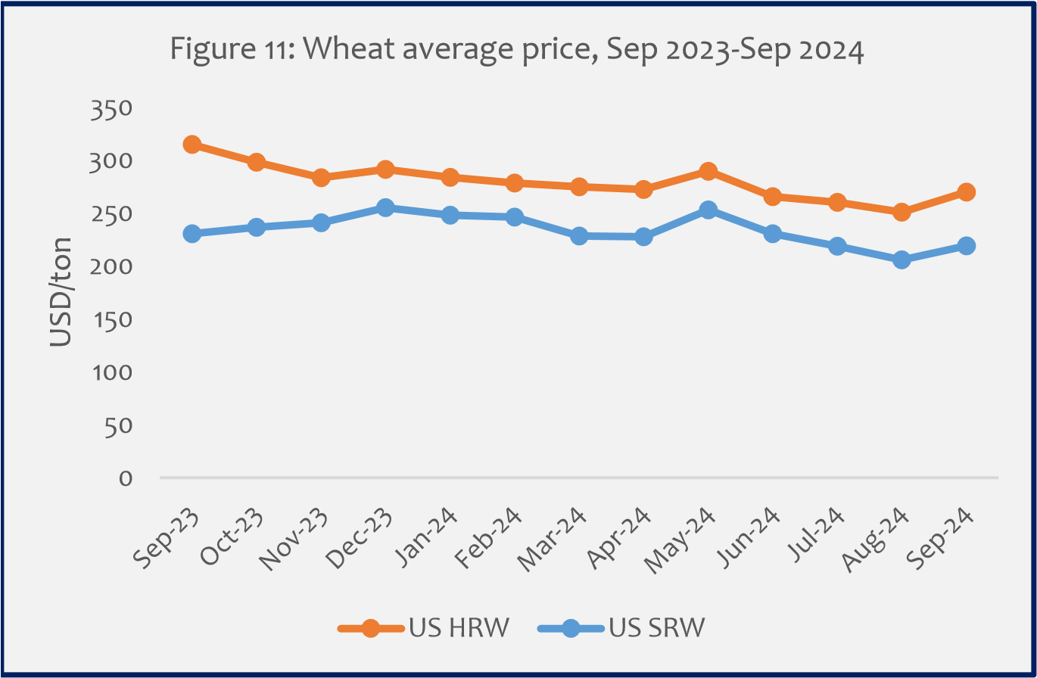

### Edible Oil (Palm)

The price of palm oil as been increasing and decreasing from September 2024 at different rates. Palm oil prices increased marginally by 5.4.41 percent in September 2024, from USD 932.63/ton in August 2024 to SD 982.83/ton in September (Figure 12). Tanzania imports a large amount of edible oil. For the fiscal year ending August 2024, the import bill was SD mil 132.3 (BoT, 2024**)**

0

200

400

600

800

1,000

1,200

Sep-23

Oct-23

Nov-23

Dec-23

Jan-24

Feb-24

Mar-24

Apr-24

May-24

Jun-24

Jul-24

Aug-24

Sep-24

USD/ton

Figure 12: Palm oil average price, Sep 2023

-

Sep 2024

**4. Farm Inputs** (Source: World Bank, 2024)

### Fertilizer

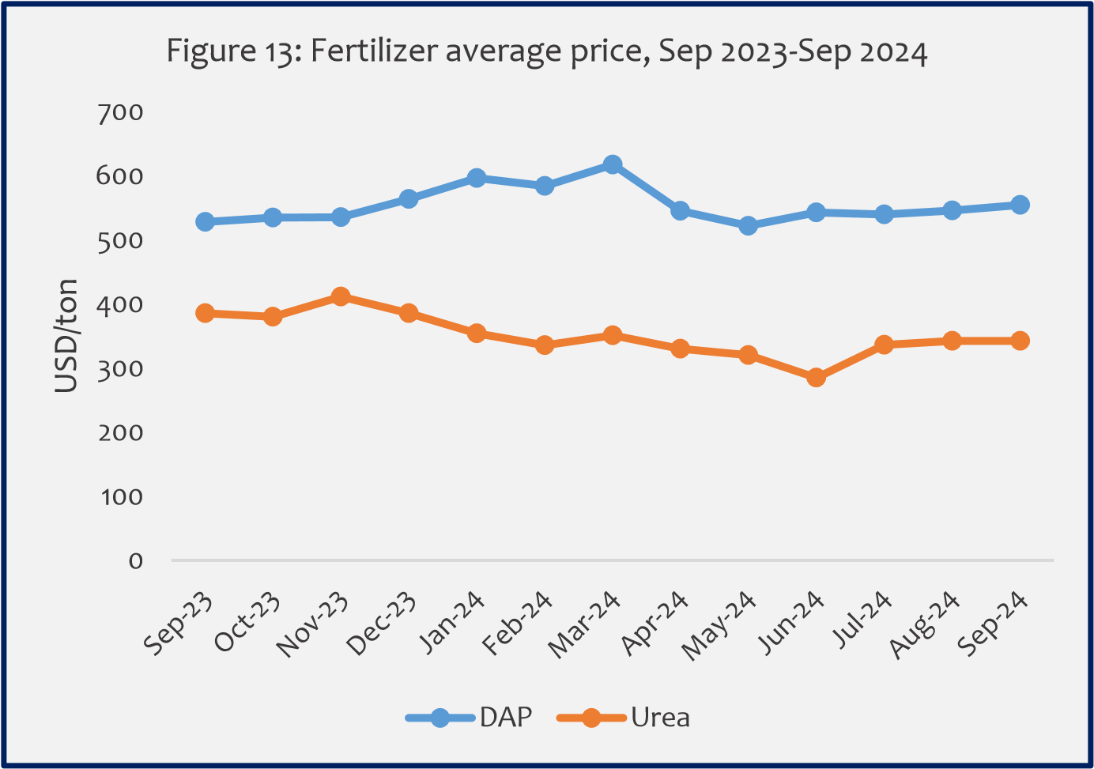Both Urea and DAP fertilizers recorded a steady decline in price changes from their pick in March 2024. In September, increase of 1.6 percent in DAP prices was observed while a Urea remains constant (Figure 13). International prices are expected to continue declining as natural gas prices fall. Tanzania imports roughly 90% of its fertilizer annual requirement. The fertilizer subsidy program, which is currently in effect, is expected to lower production costs and increase farm yield.

|  |
| --- |
| ***About the Bulletin***  This bulletin provides domestic and international markets outlook for five commodity groups including **staples** (maize, rice, beans, sorghum, and round potatoes), **traditional export crops** (coffee, cotton, tea, and tobacco), **import substitution commodities** (edible oil, and wheat) and **farm inputs** (fertilizer). This bulletin's information serves as a benchmark for key players along the respective value chains to make informed decisions.  **Disclaimer:** The views expressed in this bulletin are those of the authors and may not reflect those of the **Ministry of Agriculture (MoA)**. This bulletin is strictly for informational purposes only. The authors have made every effort to ensure accuracy of information provided; however, neither the Ministry of Agriculture nor the authors can guarantee such accuracy  **For further information, contact:**  ***Agricultural Marketing Section,*** ***P.O. Box 2182, DODOMA.***  ***Email:*** *masoko@kilimo.go.tz* |